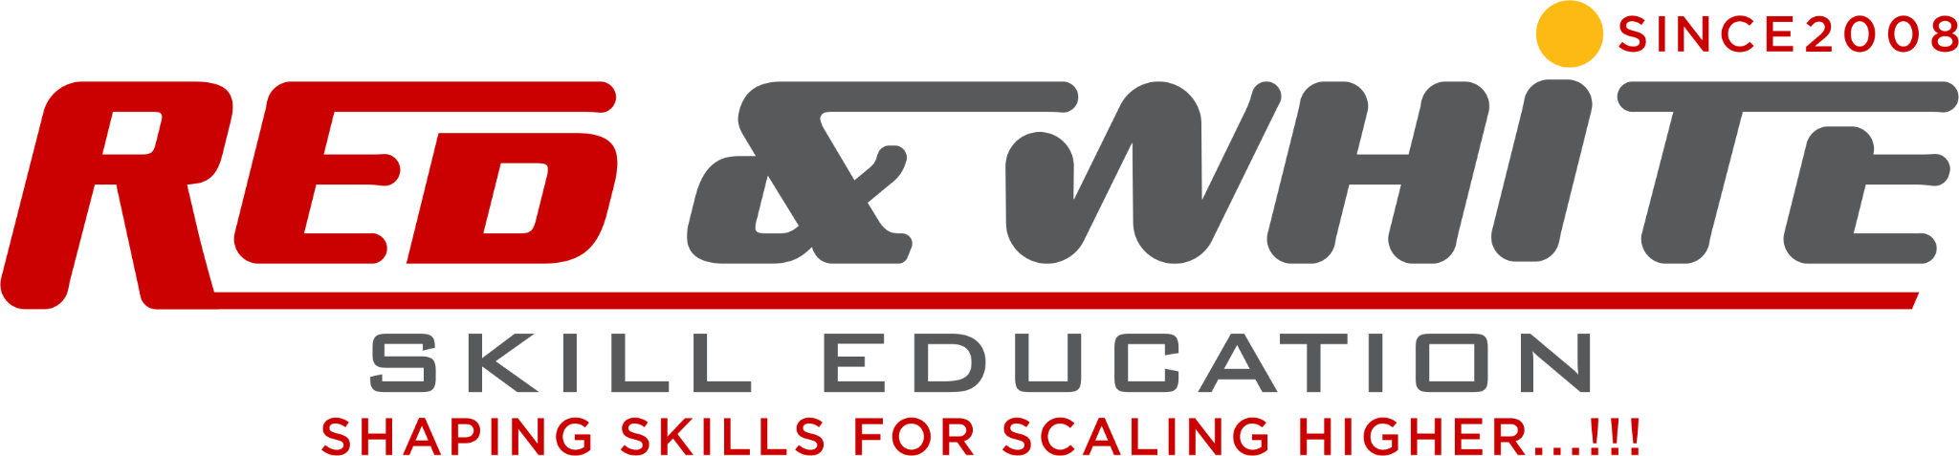

Exam Title: “Unlocking Revenue: Identifying Bottlenecks in Regional Sales Pipeline”

🧑‍🎓 Exam Type: Standalone Business Case-Based Practical

⏳ Duration: 3 Hours

📦 Dataset: A gigantic CSV dataset: RegionalSales2025.csv (Generate from AI tool)

📝 Project Task
You are hired as a freelance Business Analyst by a retail chain struggling with inconsistent sales across its regions. Your goal is to use the provided sales transaction dataset to identify bottlenecks, underperforming regions, and high-value opportunities.

💡 Instructions & Evaluation Criteria
⚠️ Note: You must use SQL for data analysis and then use Excel OR Power BI to visualize key metrics. Present your insights through charts and tables.

📂 Dataset Structure:

RegionalSales2025.csv
Column | Description
OrderID | Unique order identifier
Date | Date of transaction
CustomerID | Unique customer
Region | Region of sale (East, West, North, South)
ProductName | Name of product
Category | Product category
Quantity | No. of units sold
UnitPrice | Unit selling price
TotalAmount | Total sales amount = Quantity × UnitPrice
OrderStatus | Completed, Cancelled, Returned
SalesAgent | Assigned agent for region

🔧 PART 1 – SQL Analysis
Write SQL queries to answer the following:
- 📈 Monthly trend of sales across all regions.
- 🚫 Percentage of canceled and returned orders per region.
- 📉 Identify 3 regions/products with most revenue loss (cancelled/returned).
- 🧮 Average order value by product category.
- 🧍 Top 5 performing sales agents (by completed revenue).
- 📊 Category-wise total sales and contribution to grand total.
- 🏆 List customers with highest frequency of returns (≥ 3 times).
Save your SQL output results in CSV format or a temporary table.

📈 PART 2 – Excel or Power BI Dashboard
Based on your SQL results or the original dataset, build a Business Dashboard with:
- Heatmap or Matrix of Region vs Category Sales
- Stacked Bar Chart for OrderStatus by Region
- Line Chart showing Monthly Sales Trends
- KPI Cards:
  - Total Completed Sales
  - Total Cancellations
  - Average Order Value
  - Most Returned Product
- Use filters for Region, Category, and SalesAgent

📤 Final Submission
File | Description
SalesBottleneck.sql | SQL script with all analysis queries
BottleneckDashboard.xlsx or .pbix | Completed dashboard
ExecutiveSummary.txt | Key insights & suggested actions

🧠 Example Insights to Derive
- Which region is underperforming and why?
- Are certain agents associated with more cancellations?
- Which category needs promotion or improvement?
- Is customer dissatisfaction concentrated in a region?

Practical Exam
BUSINESS CASE STUDY

BRING ON YOUR CODING ATTITUDE

